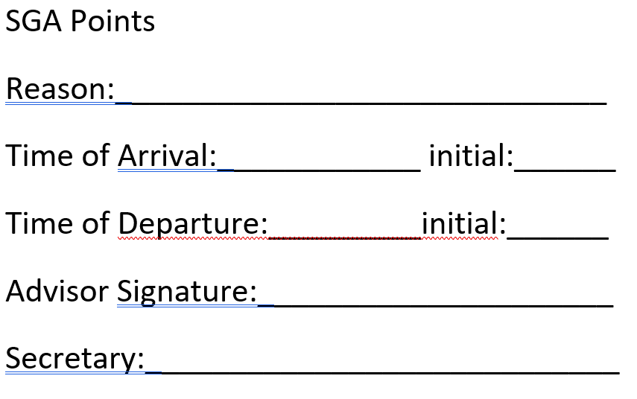
SGA Points
Reason:_____________________________
Time of Arrival:____________ initial:______
Time of Departure:_________initial:______
Advisor Signature:_____________________
Secretary:____________________________

